Typography Optimization

Definition
# Source: AI Source: Provided by: [Data Path: Persons Table -> ID Column: 1, Name_En Column: Motasem Essam] -> From: [Chatgpt (GPT‑5 Mini)] on [2/12/2026]
Typography Optimization is a web design technique that focuses on choosing and arranging fonts, text sizes, spacing, and styles to make text easy to read, visually appealing, and user-friendly.

Simple Definition
# Source: AI Source: Provided by: [Data Path: Persons Table -> ID Column: 1, Name_En Column: Motasem Essam] -> From: [Chatgpt (GPT‑5 Mini)] on [2/12/2026]
Typography Optimization = improving how text looks and reads on a website.

How Typography Optimization Works
# Source: AI Source: Provided by: [Data Path: Persons Table -> ID Column: 1, Name_En Column: Motasem Essam] -> From: [Chatgpt (GPT‑5 Mini)] on [2/12/2026]
• Choosing appropriate fonts (clear and readable)
• Setting proper font sizes for headings and body text
• Adjusting line height (spacing between lines)
• Using letter spacing and word spacing effectively
• Maintaining contrast between text and background
• Using consistent text styles across the website

Purpose of Typography Optimization
# Source: AI Source: Provided by: [Data Path: Persons Table -> ID Column: 1, Name_En Column: Motasem Essam] -> From: [Chatgpt (GPT‑5 Mini)] on [2/12/2026]
• Improve readability and clarity
• Make content easier to understand
• Create a strong visual hierarchy
• Enhance user experience
• Support the overall design and branding

Advantages
# Source: AI Source: Provided by: [Data Path: Persons Table -> ID Column: 1, Name_En Column: Motasem Essam] -> From: [Chatgpt (GPT‑5 Mini)] on [2/12/2026]
• Better readability for users
• Professional and clean design
• Improved accessibility
• Keeps users engaged longer
• Helps highlight important content

Disadvantages
# Source: AI Source: Provided by: [Data Path: Persons Table -> ID Column: 1, Name_En Column: Motasem Essam] -> From: [Chatgpt (GPT‑5 Mini)] on [2/12/2026]
• Choosing the wrong fonts can reduce readability and user experience
• Overuse of different fonts can make the design look messy and unprofessional
• Requires careful balance between style and readability
• Some fonts may not display correctly on all devices or browsers
• Poor spacing or contrast can make text hard to read
• Limited font choices may restrict creativity in some cases
• Needs testing across different screen sizes and devices to ensure clarity

Examples
# Source: AI Source: Provided by: [Data Path: Persons Table -> ID Column: 1, Name_En Column: Motasem Essam] -> From: [Chatgpt (GPT‑5 Mini)] on [2/12/2026]
• Using large, bold headings and smaller body text
• Choosing simple fonts like Arial or Roboto for readability
• Increasing line spacing in long paragraphs
• Using bold or color to highlight important words
• Keeping font styles consistent across pages

Difference Between Typography Optimization and Other Techniques
# Source: AI Source: Provided by: [Data Path: Persons Table -> ID Column: 1, Name_En Column: Motasem Essam] -> From: [Chatgpt (GPT‑5 Mini)] on [2/12/2026]
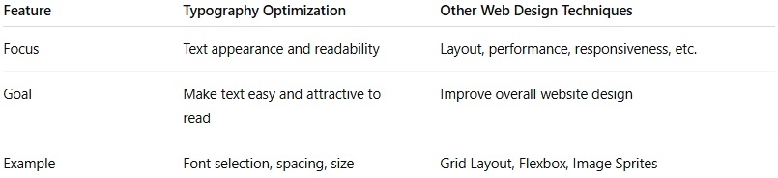
Feature | Typography Optimization | Other Web Design Techniques
Focus | Text appearance and readability | Layout, performance, responsiveness, etc.
Goal | Make text easy and attractive to read | Improve overall website design
Example | Font selection, spacing, size | Grid Layout, Flexbox, Image Sprites

